**BIO-TECH STARTUP MARKET SEGMENTATION**

**T-CORVUS**

**CONTRIBUTORS** : **Prachi Nikhare, A Chingkheinganba Singha,**

**Parth Rajendra Salunke, Akash Gupta**

**GITHUB LINK :** [**https://github.com/prachinikhare/BIO-TECH-STARTUP-MARKET-SEGMENTATION**](https://github.com/prachinikhare/BIO-TECH-STARTUP-MARKET-SEGMENTATION)

**ABSTRACT**

This chapter discusses an innovative health technology and development process in the healthcare industry, challenges and trends in the healthcare system, and health technologies for the future. The chapter concludes by recommending methodologies for developing health technology to start-ups and entrepreneurs.

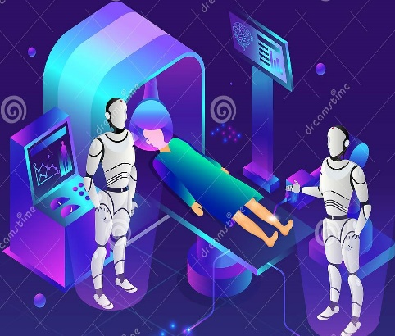

**1**

**PROBLEM STATEMENT**

You are a team working under a Bio-Tech Startup going to launch its Home Checkup Service with Online Booking offering the following initial services.

1. Full Body Checkup with a Bio-Tech Device based on Blood Samples

2. Online Health Techs offering i. Diabetes checkup device, ii. Blood Pressure checkup device, iii. Vitamins deficiency checkup device.

You have to analyse Medical Market in India with respect to the given problem statement using Segmentation analysis and come up with a feasible strategy to enter the market, targeting the segments most likely to use their product in terms of Geographic, Demographic, Psychographic, Behavioral. (Interns have the choice to add more segments)

**DATA SOURCES (DATA COLLECTION)**

1. **Some of the different data collecting sources:**

* Collecting new data from internet and other sources
* Using the previously collected and stored data
* Reusing someone else’s data
* Purchasing data

**2. The data collection methods depend on the following:**

• The research problem under study  
 • The research design  
 • The information gathered about the variable

**2**

**DATA PRE-PROCESSING (STEPS AND LIBRARIES USED)**

**Step 1. Loading the data set**

**Importing libraries:**

The absolutely first thing we need to do is to import libraries for data preprocessing. There are lots of libraries available, but the most popular and important Python libraries for working on data are Numpy, Matplotlib, and Pandas. **Numpy** is the library used for all mathematical things. **Pandas** is the best tool available for importing and managing datasets. Matplotlib

(Matplotlib.pyplot) is the library to make charts.

**Step 2. Loading data into pandas**

we downloaded your data set and named it as a .csv file, we need to load it into a pandas DataFrame to explore it and perform some basic cleaning tasks removing information you don’t need that will make data processing slower.

**Step 3. Exploring the data set**

**Deciding on a target column**

With a filtered data set explored, we need to create a matrix of dependent variables and a vector of independent variables. At first, you should decide on the appropriate column to use as a target column for modeling based on the question we want to answer. For example, if you're going to predict the development of cancer, or the chance the credit will be approved, we need to find a column with the status of the disease or loan granting ad use it as the target column.

### Step 4. Preparing the Features for Machine Learning

Finally, it’s time to do the preparatory work to feed the features for

ML algorithms. To clean the data set, we need to **handle missing values**

**and categorical features**, because the mathematics underlying most machine learning models assumes that the data is numerical and

contains no missing values. Moreover, the **scikit-learn** library returns an error if we try to train a model like K-Means Clustering and Hierarchical Clustering. using data that contain missing or non-numeric values.

Clustering algorithm is a technique that assists customersegmentation which is a process of classifying similar customers into the same segment. Clustering algorithm helps to better understand customers, in terms of both static demographics and dynamic behaviors.

**3**

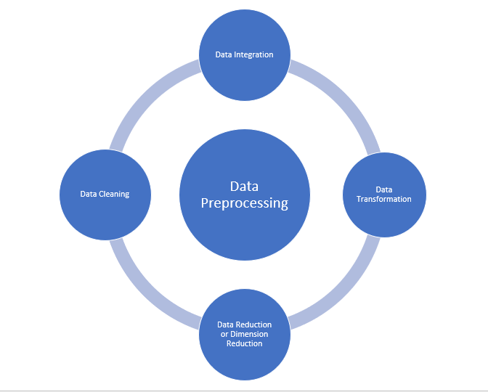

**DATA VISUALIZATION**

1. **BLOOD PRESSURE**

# Blood pressure data visualization for the management of

# hypertension: designing for patient and physician information needs

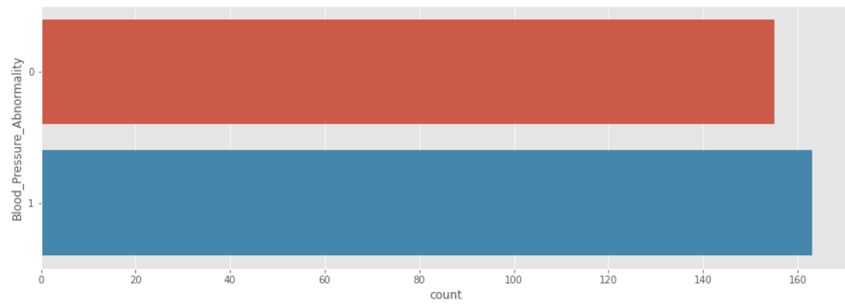

**4**

1. **VITAMINS**

**The data used in the report has been collected from a survey during the year 2016 – 2018. It includes the data about the deficiency of Vitamin A and Vitamin D among children aged between 0 – 6 in various state of India.**

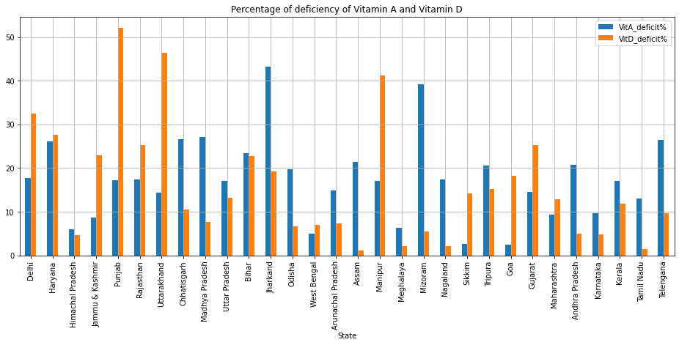

In the above plot, we observe that Jharkhand and Mizoram have higher percentage of Vitamin A deficiency whereas Punjab, Uttarakhand and Manipur have higher percentage of Vitamin D deficiency.

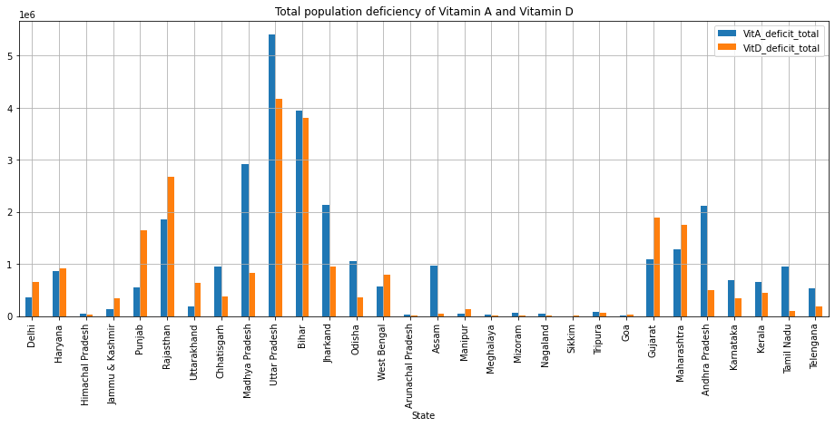

In the above plot, we observe that Uttar Pradesh has the highest

population of Vitamin A deficiency and Uttar Pradesh and Bihar have higher

population of Vitamin D deficiency.

**5**

1. **DIABETES**

Hypertension, also known as high or raised blood pressure, is a condition in which the blood vessels have persistently raised pressure. Blood is carried from the heart to all parts of the body in the vessels. Each time the heart heats it pumps blood into the vessels.

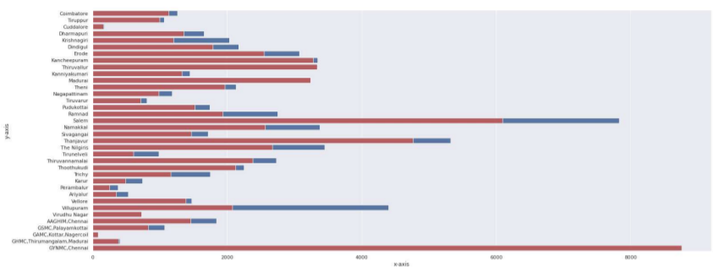

**MODEL BUILDING**

Finding the optimal clusters using:

i) K-Means

ii) Hierarchical Clustering (Agglomerative)

iii) Silhouette Score

iv) Plotting Elbow Method

v) Finding the Segment Distribution for each cluster

vi) Performing Profiling

1. **BLOOD PRESSURE**

* **Step 1: Finding the Cophenetic Distance Correlation Coefficient for different Linkages**

Conclusion: For the Agglomerative Clustering, the Cophenet distance correlation coefficient helps in deciding which linkage method is the most beneficial for the dataset. The higher the coefficient, the better it is. From the above, the best method is Average computed using City Block distance.

**6**

* **Step 2:The Optimal clusters using KMeans, Silhouette Coefficient Score  for both K-Means and Agglomerative Clustering**

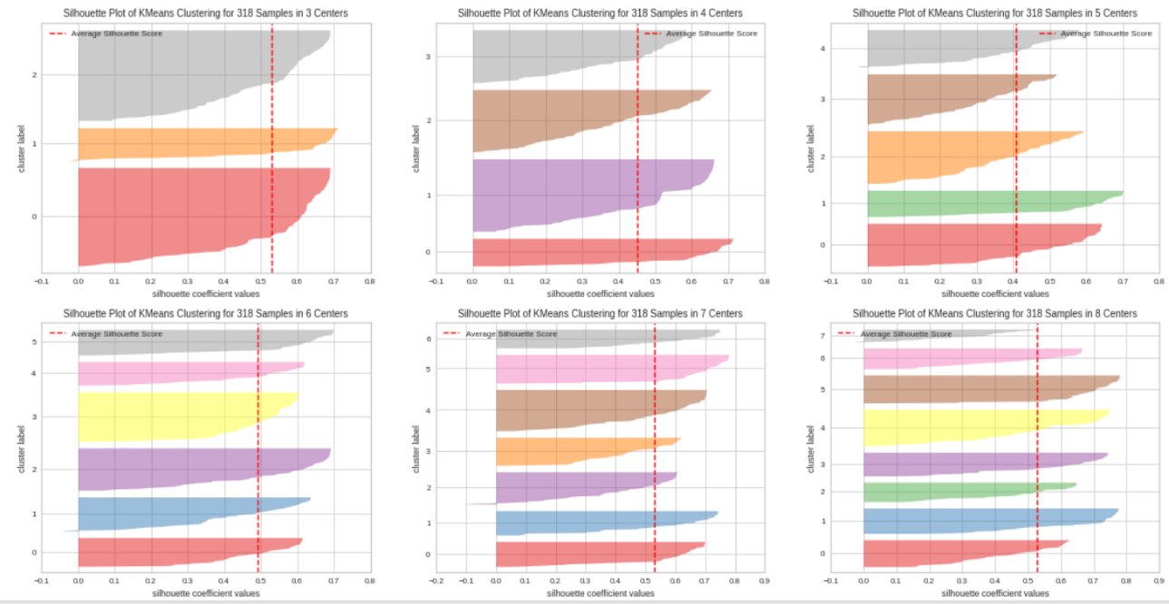

* **Step 3: Elbow graph**

Inertia or Sum of Squared Errors within the Clusters is also known as

the Cluster Errors. Cluster error will decrease after some Clusters

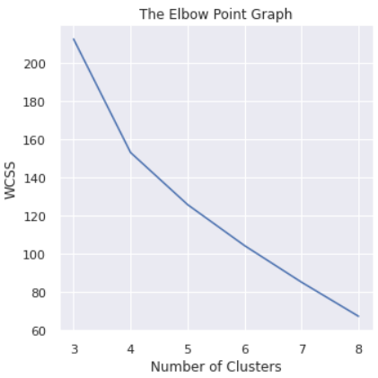

**7**

* **Step 4: Plotting All The Clusters And Their Centroids**

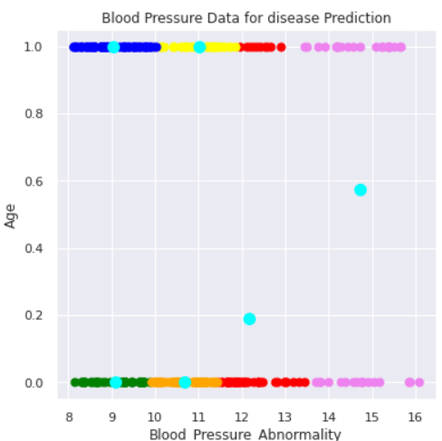

* **Step 5: Plotting the Silhouette Score for the clusters found from**

**K-Means and Agglomerative Clustering**

**sil_kmeans sil_agc**

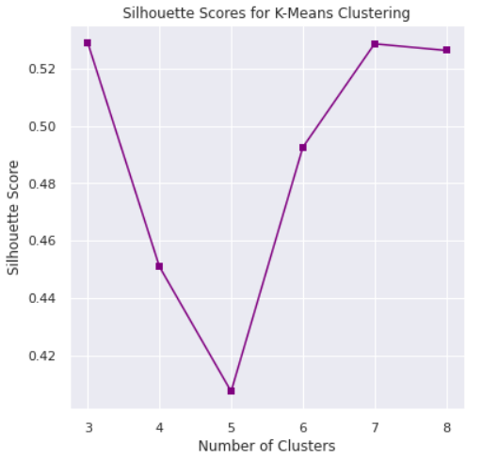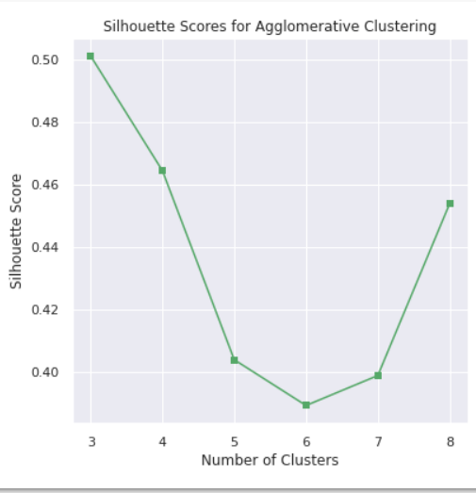

## **Step 6 : Segment Distribution**

Segment distribution gives the percentage of values in each Segment

**i)** Making K-Means Cluster and Labels for finding out the

distribution of Segments and then performing Profiling

1)K = 3, 2)K = 4, 3)K = 5, 4)K = 6, 5)K = 7, 6)K = 8

**ii)** The Segment Distribution for cluster 1)K = 3, 2)K = 4,

3)K = 5, 4)K = 6, 5)K = 7, 6)K = 8

**8**

* **Step 7 : Profiling And Describing Potential Segments**

The goal of Profiling is to be able to differentiate between the groups with the proper distinction that means each group has some unique characteristics about it and then that cluster is the ideal solution to segment the values.

Steps to do Profiling are: 1) Find the count of each segment (value_counts) ----> that gives how many observations or records are present in each segment 2) For each of the variable: find the overall average and the individual segment-wise average 3) Perform the above two steps for each K value to find the best profiling

**Step 1 of Profiling :-** Finding how many observations or records are present in each segment

## **Step 2 of Profiling :-** For each of the variable : find the overall average and the individual segment wise average.

A good indication of the distribution of data is the mean value, hence will find the average value for each variable and for each cluster.

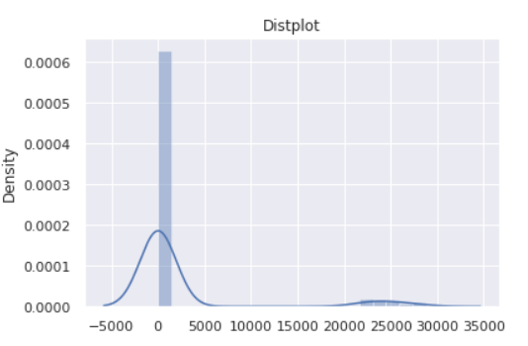

**9**

**2. VITAMINS**

**i) Elbow graph**

Inertia or Sum of Squared Errors within the Clusters is also

Known as the Cluster Errors. Cluster error will decrease

after some Clusters.

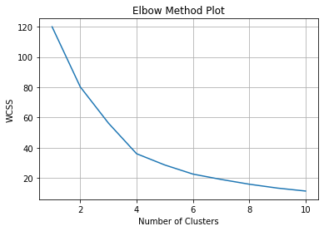

## **ii) Segment Distribution**

Segment distribution gives the percentage of values in

each Segment.

Making K-Means Cluster and Labels for finding out the

distribution of Segments

1) K = 3, 2) K = 4, 3) K = 5, 4) K = 6

The Segment Distribution for cluster 1) K = 3, 2) K = 4,

3) K = 5, 4) K = 6

Plotting the Silhouette Score for the clusters found from

K-Means.

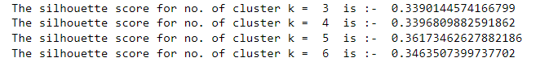

**10**

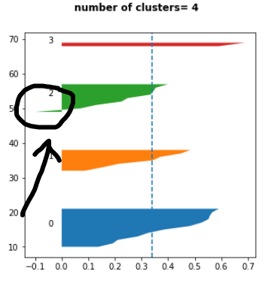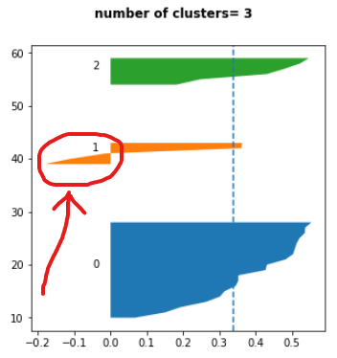

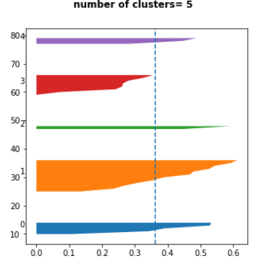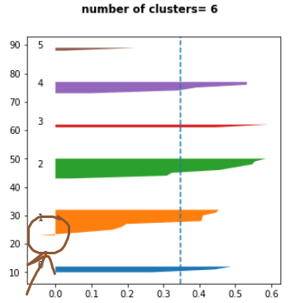

From above, we observe that the Silhouette Score = 0.36173462627882186 is the highest for number of clusters = 5

**iii) States in Cluster**

* **States in Cluster 1 are ['Delhi' 'Haryana' 'Punjab' 'Uttarakhand' 'Manipur']**
* **States in Cluster 2 are ['Himachal Pradesh' 'Jammu & Kashmir' 'West**

**Bengal' 'Arunachal Pradesh' 'Meghalaya' 'Nagaland' 'Sikkim' 'Tripura' 'Goa'**

**'Karnataka' 'Kerala' 'Tamil Nadu']**

* **States in Cluster 3 are ['Uttar Pradesh' 'Bihar']**
* **States in Cluster 4 are ['Chhatisgarh' 'Madhya Pradesh' 'Jharkand'**

**'Odisha' 'Assam' 'Mizoram' 'Andhra Pradesh' 'Telengana']**

* **States in Cluster 5 are ['Rajasthan' 'Gujarat' 'Maharashtra']**

**11**

**3. DIABETES**

**i) Elbow graph**

Inertia or Sum of Squared Errors within the Clusters is also

Known as the Cluster Errors. Cluster error will decrease

after some Clusters.

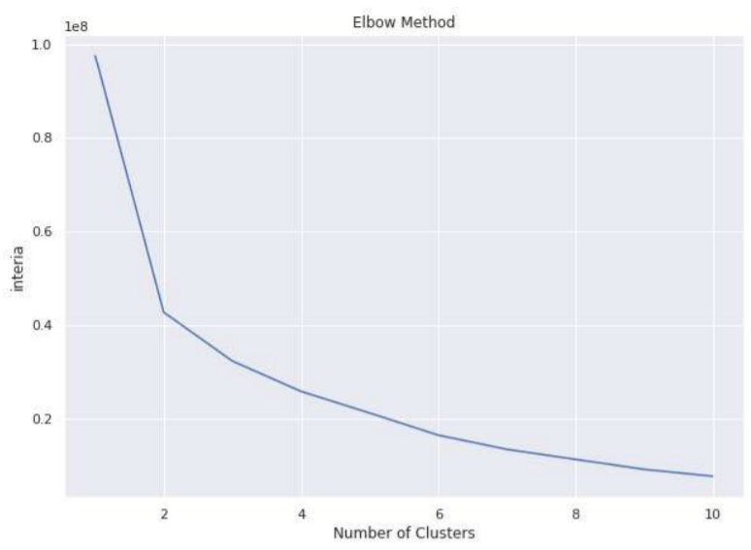

**ii) States in Cluster**

States wise visualization with Clusters

Making K-Means Cluster and Labels for finding out the

distribution of Segments

1) K = 2, 2) K = 4, 3) K = 6, 4) K = 8, 5) K = 10

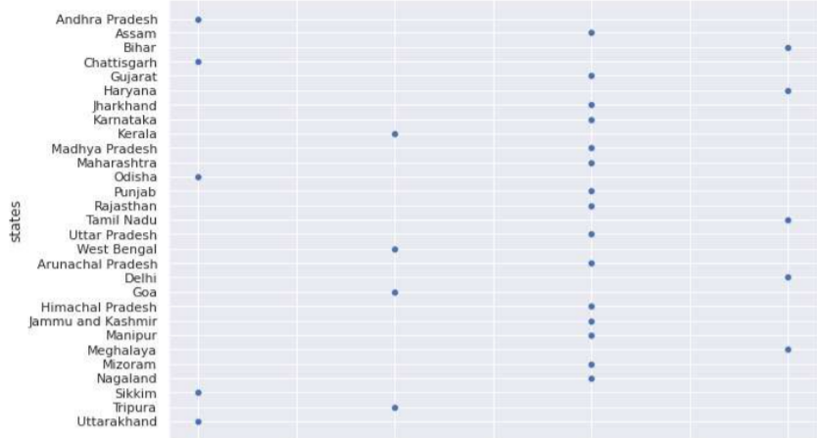

**12**

**SELECTION OF TARGET SEGMENT**

Target marketing in healthcare is the practice of marketing your healthcare center to your target audience by using strategies like audience research, segmentation, and more. With healthcare target marketing, you can better reach your ideal client or patient.

## **Four ways to define your target audience**

There are few points that will help you find the right target audience for

your marketing initiatives. However, the goal should be to specific about

the target audience you select so that your **healthcare marketing**

campaigns provide expected results. Let us explore the details here.

* **Geo-location**: When researching your target audience, you will have to decide about the location that you will focus on in your marketing campaigns. This decision will be based upon physical location of your establishment and the distance from which you expect patients to visit.
* **Demographics**: Marketing campaigns are to be created on the basis of chosen demographics of your audience. For instance, you will have analyze the gender, age, education, size of family, occupation, household income, and similar other details while deciding about demographics to target.
* **Psychographics**: As part of psychographical analysis, few of the points to look into would be lifestyle, behavior, and personality of your audience base. In addition, you need to examine whether the audience is responsive to new innovations.
* **Behavior**: You need to analyze needs of your audience base as well as evaluate their knowledge level. Additionally, you need to check the response they provide to specific health care services and products.

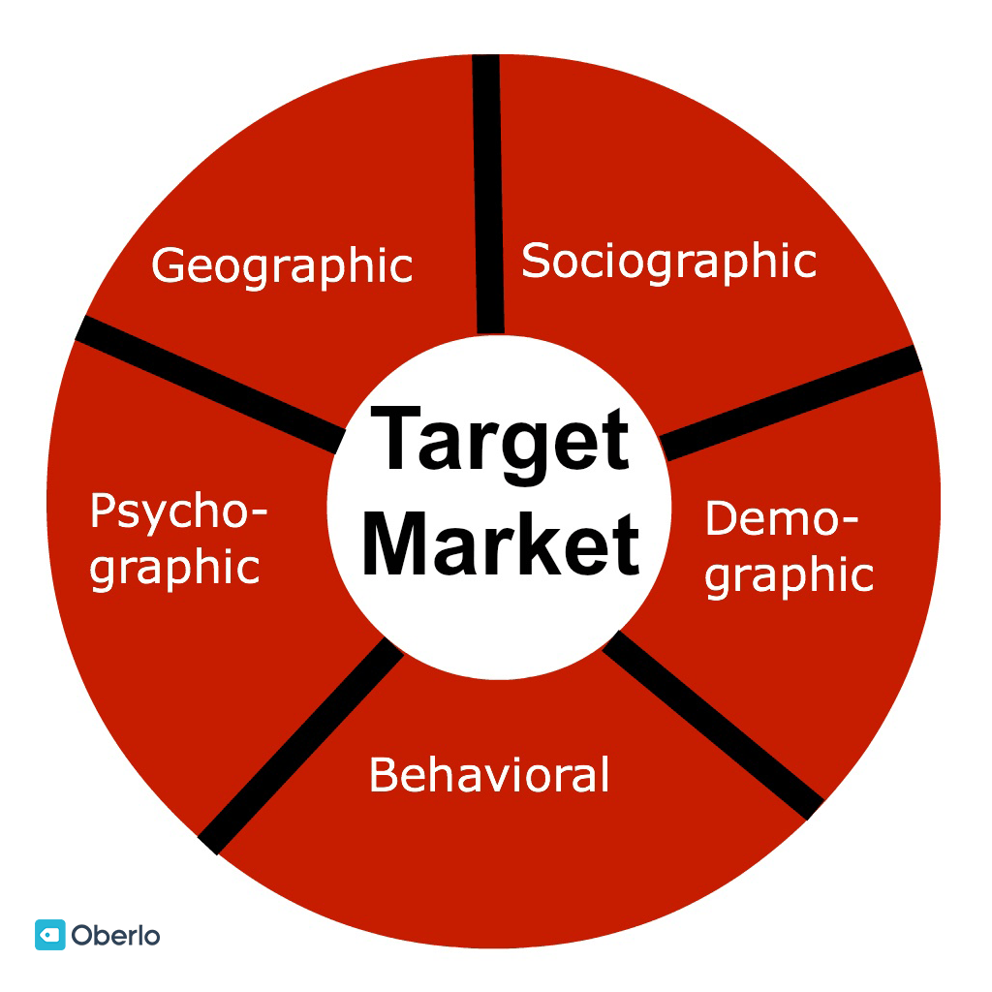

**13**

## **Ai Healthcare Market Segmentation**

The AI in healthcare market is segmented on the basis of offering,

algorithm, application, end user, and region. By offering, the market

is divided into hardware, software, and services. By algorithm, it is

classified into deep learning, querying method, natural language

processing, and context aware processing. By application, it is

fragmented into robot-assisted surgery, virtual nursing

assistant, administrative workflow assistance, fraud detection, dosage

error reduction, clinical trial participant identifier, preliminary diagnosis,

and others. By end user, it is categorized into healthcare providers, pharmaceutical & biotechnology companies, patients, and payers. Region-wise, it is analyzed across North America, Europe, Asia-Pacific, and LAMEA.

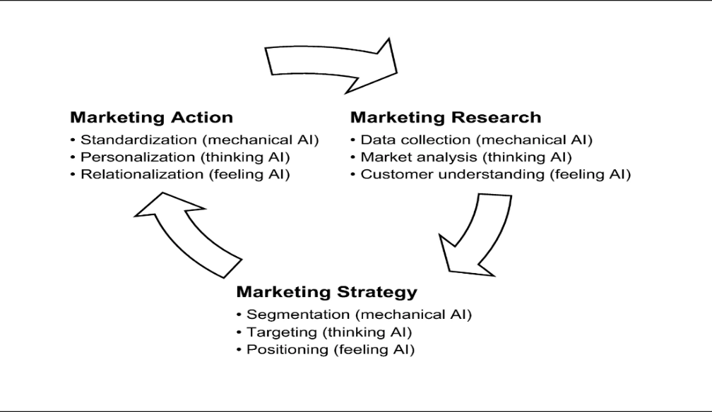

**14**

**CUSTOMIZING THE MARKETING MIX**

A marketing programme uniquely designed for a particular customer. In international marketing the term describes a marketing programme designed uniquely for a particular country.

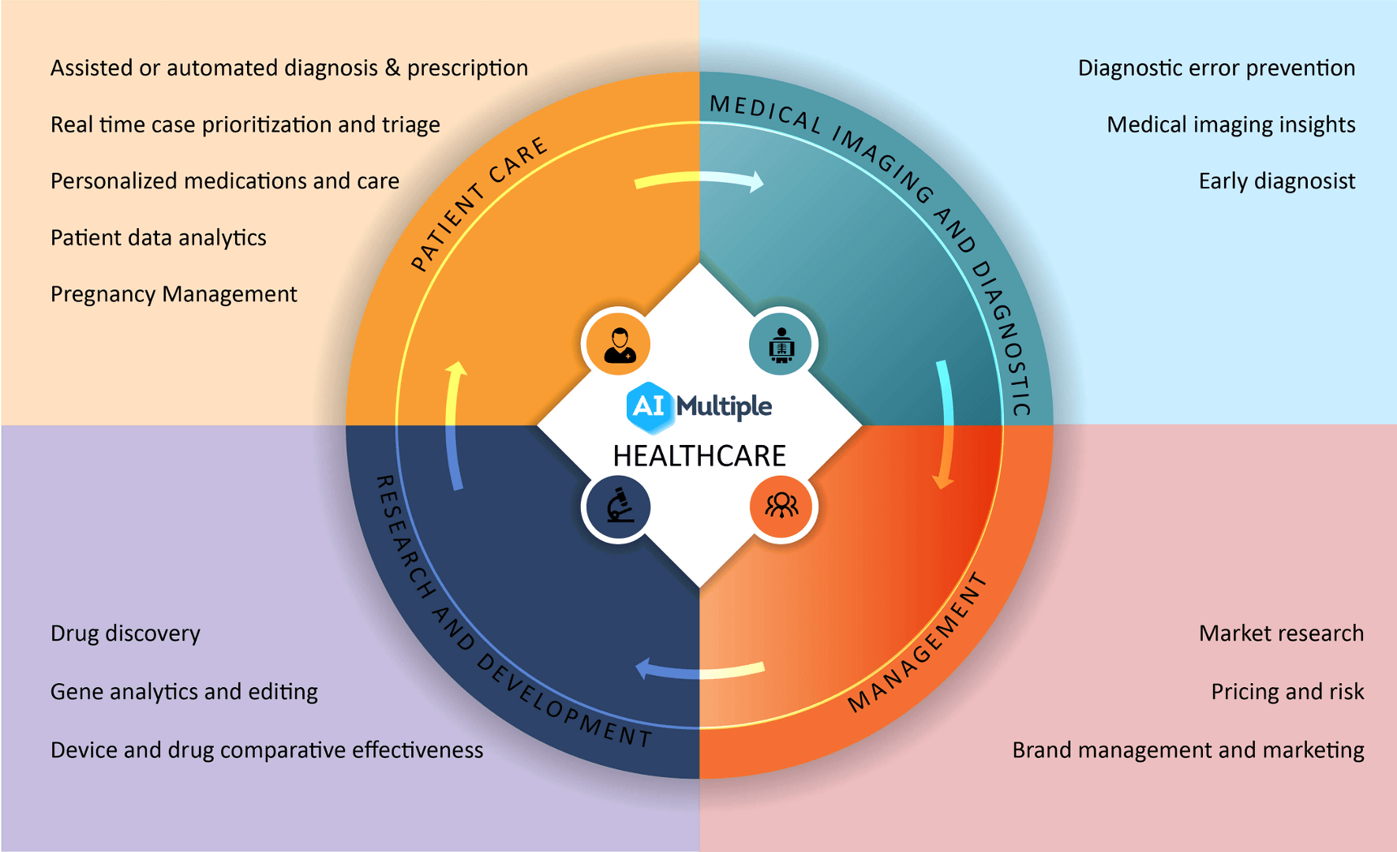

A marketing mix includes multiple areas of focus as part of a comprehensive marketing plan. The term often refers to a common classification that beganas the four Ps: **product, price, placement, and promotion**. Effective marketing touches on a broad range of areas as opposed to fixating on one message.

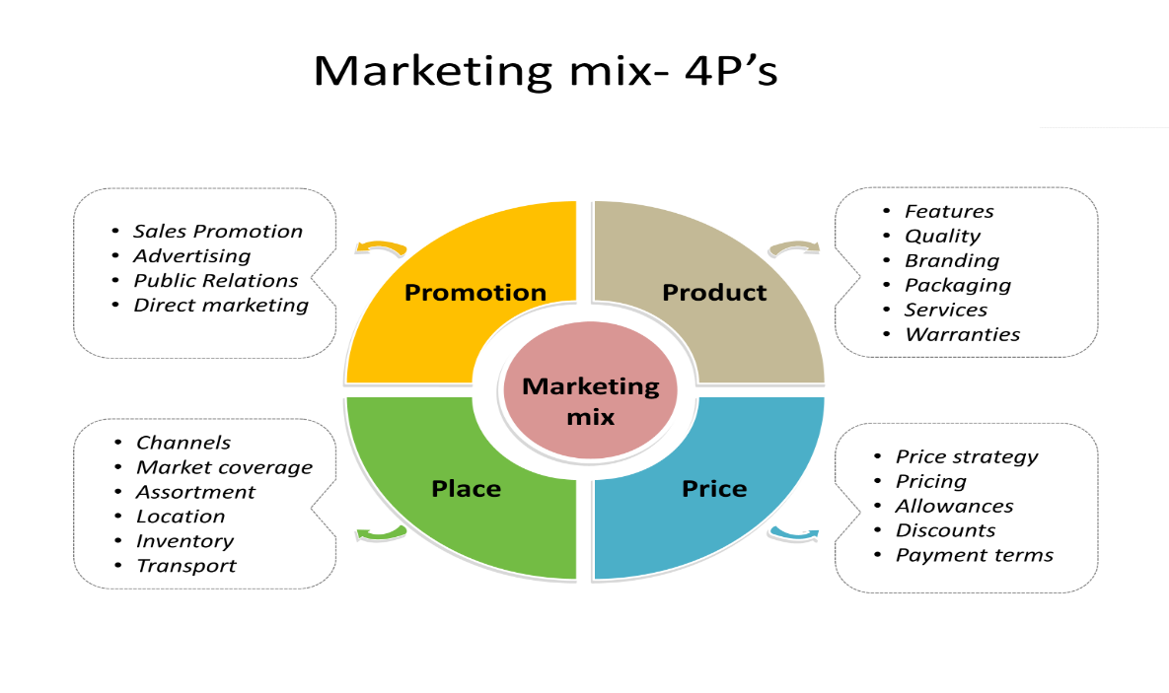

**15**

### i) Product

This represents an item or service designed to satisfy customer needs and wants. To effectively market a product or service, it's important to identify what differentiates it from competing products or services. It's also important to determine if other products or services can be marketed in conjunction with it.

### ii) Price

The sale price of the product reflects what consumers are willing to pay for it. Marketing professionals need to consider costs related to research and development, manufacturing, marketing, and distribution—otherwise known as cost-based pricing. Pricing based primarily on consumers' perceived quality or value is known as [value-based pricing](https://www.investopedia.com/terms/v/valuebasedpricing.asp).

### iii) Placement

The type of product sold is important to consider when determining areas of distribution. Basic consumer products, such as paper goods, often are readily available in many stores. Premium consumer products, however, typically are available only in select stores. Another consideration is whether to place a product in a physical store, online, or both.

### iv) Promotion

Joint marketing campaigns also are called a promotional mix. Activities might include advertising, sales promotion, personal selling, and public relations. A key consideration should be for the budget assigned to the marketing mix. Marketing professionals carefully construct a message that often incorporates details from the other three Ps when trying to reach their [target audience](https://www.investopedia.com/terms/t/target-market.asp). Determination of the best mediums to communicate the message and decisions about the frequency of the communication also are important.

**16**

**CONCLUSION**

• The primary aim of AI in healthcare is to analyze relationships between

or treatment techniques and patient outcomes.

• AI can achieve fast and accurate Diagnostics.

• It will be very helpful to reduce the human errors as well as the cost

of treatment. Artificial Intelligence is definitely improving the

healthcare industry. From predictive medical care and more

accurate diagnosis to motivating the patients to take care of their

health, AI will certainly continue enhancing the patient experience

and healthcare expertise in general.

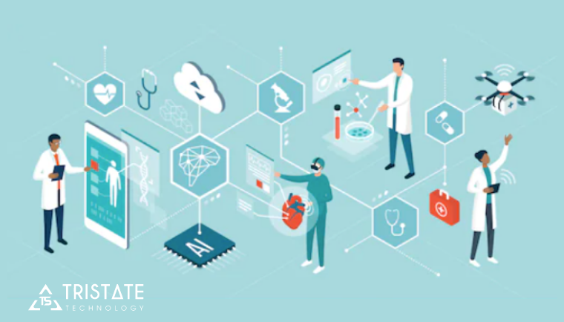

### 

### 17

**REFERENCES**

1. Miller D.D., Brown E.W. Artificial intelligence in medical practice: the question to the answer? *Am J Med.*2018;131(2):129–133. [[PubMed](https://www.ncbi.nlm.nih.gov/pubmed/29126825)] [[Google Scholar](https://scholar.google.com/scholar_lookup?journal=Am+J+Med&title=Artificial+intelligence+in+medical+practice:+the+question+to+the+answer?&author=D.D.+Miller&author=E.W.+Brown&volume=131&issue=2&publication_year=2018&pages=129-133&pmid=29126825&)]

2. Kirch D.G., Petelle K. Addressing the physician shortage: the peril of ignoring demography. *JAMA.*2017;317(19):1947–1948. [[PubMed](https://www.ncbi.nlm.nih.gov/pubmed/28319233)] [[Google Scholar](https://scholar.google.com/scholar_lookup?journal=JAMA&title=Addressing+the+physician+shortage:+the+peril+of+ignoring+demography&author=D.G.+Kirch&author=K.+Petelle&volume=317&issue=19&publication_year=2017&pages=1947-1948&pmid=28319233&)]

3. Combi C., Pozzani G., Pozzi G. Telemedicine for developing countries. *Appl Clin Inform.*2016;07(04):1025–1050. [[PMC free article](https://www.ncbi.nlm.nih.gov/pmc/articles/PMC5228142/)] [[PubMed](https://www.ncbi.nlm.nih.gov/pubmed/27803948)] [[Google Scholar](https://scholar.google.com/scholar_lookup?journal=Appl+Clin+Inform&title=Telemedicine+for+developing+countries&author=C.+Combi&author=G.+Pozzani&author=G.+Pozzi&volume=07&issue=04&publication_year=2016&pages=1025-1050&)]

4. Bresnick J. Artificial intelligence in healthcare market to see 40% CAGR surge; 2017.

5. Lee K.-F. *AI superpowers: China, Silicon Valley, and the new world order.* 1st ed. Houghton Mifflin Harcourt; 2019. [[Google Scholar](https://scholar.google.com/scholar_lookup?title=AI+superpowers:+China,+Silicon+Valley,+and+the+new+world+order&author=K.-F.+Lee&publication_year=2019&)]

6. King D, DeepMind’s health team joins Google Health.

7. Hoyt R.E., Snider D., Thompson C., Mantravadi S. IBM Watson Analytics: automating visualization, descriptive, and predictive statistics. *JMIR Public Health Surveill.*2016;2(2):e157. [[PMC free article](https://www.ncbi.nlm.nih.gov/pmc/articles/PMC5080525/)] [[PubMed](https://www.ncbi.nlm.nih.gov/pubmed/27729304)] [[Google Scholar](https://scholar.google.com/scholar_lookup?journal=JMIR+Public+Health+Surveill&title=IBM+Watson+Analytics:+automating+visualization,+descriptive,+and+predictive+statistics&author=R.E.+Hoyt&author=D.+Snider&author=C.+Thompson&author=S.+Mantravadi&volume=2&issue=2&publication_year=2016&pages=e157&pmid=27729304&)]

8. Marr B. How is AI used in healthcare—5 powerful real-world examples that show the latest advances. Forbes; 2018.

9. Kalis B, Collier M, Fu R. 10 promising AI applications in health care. Harvard Business Review; 2018.

10. Singhal S, Carlton S. The era of exponential improvement in healthcare? McKinsey Co Rev.; 2019.

11. Konieczny L, Roterman I. Personalized precision medicine. Bio-Algorithms Med-Syst 2019; 15.

12. Love-Koh J. The future of precision medicine: potential impacts for health technology assessment. *Pharmacoeconomics.*2018;36(12):1439–1451. [[PMC free article](https://www.ncbi.nlm.nih.gov/pmc/articles/PMC6244622/)] [[PubMed](https://www.ncbi.nlm.nih.gov/pubmed/30003435)] [[Google Scholar](https://scholar.google.com/scholar_lookup?journal=Pharmacoeconomics&title=The+future+of+precision+medicine:+potential+impacts+for+health+technology+assessment&author=J.+Love-Koh&volume=36&issue=12&publication_year=2018&pages=1439-1451&pmid=30003435&)]

13. Kulski JK. Next-generation sequencing—an overview of the history, tools, and ‘omic’ applications; 2020.

14. Hughes J.P., Rees S., Kalindjian S.B., Philpott K.L. Principles of early drug discovery. *Br J Pharmacol.*2011;162(6):1239–1249. [[PMC free article](https://www.ncbi.nlm.nih.gov/pmc/articles/PMC3058157/)] [[PubMed](https://www.ncbi.nlm.nih.gov/pubmed/21091654)] [[Google Scholar](https://scholar.google.com/scholar_lookup?journal=Br+J+Pharmacol&title=Principles+of+early+drug+discovery&author=J.P.+Hughes&author=S.+Rees&author=S.B.+Kalindjian&author=K.L.+Philpott&volume=162&issue=6&publication_year=2011&pages=1239-1249&pmid=21091654&)]

15. Ekins S. Exploiting machine learning for end-to-end drug discovery and development. *Nat Mater.*2019;18(5):435–441. [[PMC free article](https://www.ncbi.nlm.nih.gov/pmc/articles/PMC6594828/)] [[PubMed](https://www.ncbi.nlm.nih.gov/pubmed/31000803)] [[Google Scholar](https://scholar.google.com/scholar_lookup?journal=Nat+Mater&title=Exploiting+machine+learning+for+end-to-end+drug+discovery+and+development&author=S.+Ekins&volume=18&issue=5&publication_year=2019&pages=435-441&pmid=31000803&)]

16. Zhang L., Tan J., Han D., Zhu H. From machine learning to deep learning: progress in machine intelligence for rational drug discovery. *Drug Discov Today.*2017;22(11):1680–1685. [[PubMed](https://www.ncbi.nlm.nih.gov/pubmed/28881183)] [[Google Scholar](https://scholar.google.com/scholar_lookup?journal=Drug+Discov+Today&title=From+machine+learning+to+deep+learning:+progress+in+machine+intelligence+for+rational+drug+discovery&author=L.+Zhang&author=J.+Tan&author=D.+Han&author=H.+Zhu&volume=22&issue=11&publication_year=2017&pages=1680-1685&pmid=28881183&)]

17. Lavecchia A. Deep learning in drug discovery: opportunities, challenges and future prospects. *Drug Discov Today.*2019;24(10):2017–2032. [[PubMed](https://www.ncbi.nlm.nih.gov/pubmed/31377227)] [[Google Scholar](https://scholar.google.com/scholar_lookup?journal=Drug+Discov+Today&title=Deep+learning+in+drug+discovery:+opportunities,+challenges+and+future+prospects&author=A.+Lavecchia&volume=24&issue=10&publication_year=2019&pages=2017-2032&pmid=31377227&)]

**18**